St. Andrew’s Episcopal Cathedral
A Community Celebration of Holy Eucharist
Honoring all First Responders
September 11, 2019 | Rite II Noon
305 E. Capitol St. | Jackson, MS 39201 standrews.ms 601-354-1535
Welcome to St. Andrew’s Episcopal Cathedral! We are glad we can worship together today. If you are a newcomer, please complete a Welcome Card found in the pew and place it in the offering plate so we can extend our welcome beyond this service. Following the service, join us for a free hamburger lunch in the Parish Hall.

.

The Word of God
Carillon Prelude A selection of patriotic music and American hymns.

All stand at the ringing of the tower bell and join in singing | Hymn, H-1982 #680 O God, our help in ages past St. Anne  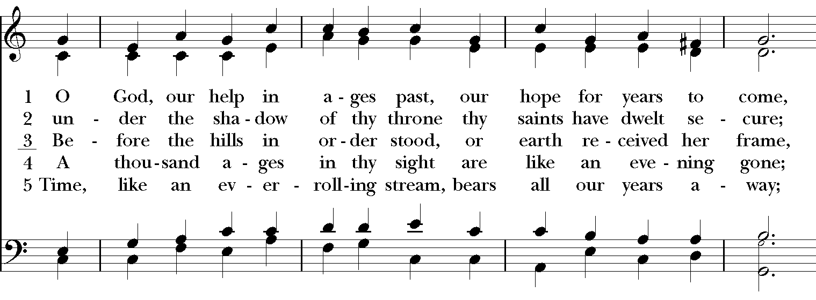  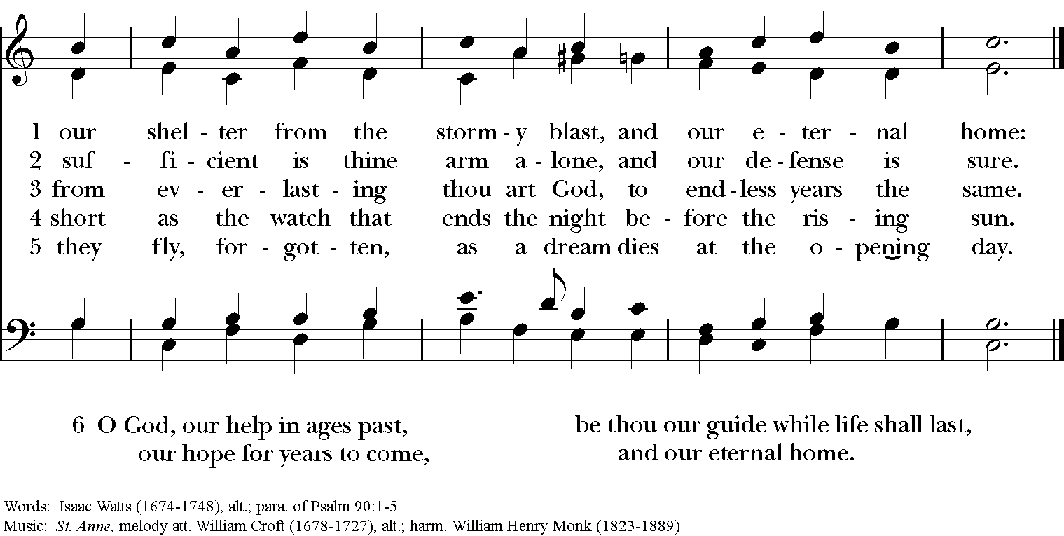
Opening Acclamation
Presider Blessed be the one, holy, and living God.
People Glory to God for ever and ever. Amen.
Collect of the Day
Presider The Lord be with you.
People And also with you.
Presider Let us pray.
God our rock and refuge: Keep us safe in your care and strengthen us with your grace, that we may pray to you faithfully and love one another boldly; following the example of Jesus, who with you and the Holy Spirit lives and reigns for ever and ever. Amen.
All are now seated for the readings from Holy Scripture. | A Reading from Isaiah Isaiah 43:1-5  But now thus says the Lord, he who created you, O Jacob, he who formed you, O Israel: Do not fear, for I have redeemed you; I have called you by name, you are mine. When you pass through the waters, I will be with you; and through the rivers, they shall not overwhelm you; when you walk through fire you shall not be burned, and the flame shall not consume you. For I am the Lord your God, the Holy One of Israel, your Savior. I give Egypt as your ransom, Ethiopia and Seba in exchange for you. Because you are precious in my sight, and honored, and I love you, I give people in return for you, nations in exchange for your life. Do not fear, for I am with you; I will bring your offspring from the east, and from the west I will gather you.  Reader The Word of the Lord.  People Thanks be to God.
Said by all | Psalm 139:1-11
 | 1 Lord, you have searched me out and known me; *  you know my sitting down and my rising up; you discern my thoughts from afar.  2 You trace my journeys and my resting places* and are acquainted with all my ways.  3 Indeed, there is not a word on my lips,  but you, O Lord, know it altogether.  4 You press upon me behind and before *  and lay your hand upon me.  5 Such knowledge is too wonderful for me; *  it is so high that I cannot attain to it.  6 Where can I go then from your Spirit? *  where can I flee from your presence? | 7 If I climb up to heaven, you are there; *  if I make the grave my bed, you are there also.  8 If I take the wings of the morning *  and dwell in the uttermost parts of the sea,  9 Even there your hand will lead me *  and your right hand hold me fast.  10 If I say, “Surely the darkness will cover me, *  and the light around me turn to night,”  11 Darkness is not dark to you; the night is as bright as the day; *  darkness and light to you are both alike.
A Reading from Paul’s Second Letter to the Corinthians 2 Corinthians 4:16-5:5
So we do not lose heart. Even though our outer nature is wasting away, our inner nature is being renewed day by day. For this slight momentary affliction is preparing us for an eternal weight of glory beyond all measure, because we look not at what can be seen but at what cannot be seen; for what can be seen is temporary, but what cannot be seen is eternal. For we know that if the earthly tent we live in is destroyed, we have a building from God, a house not made with hands, eternal in the heavens. For in this tent we groan, longing to be clothed with our heavenly dwelling— if indeed, when we have taken it off we will not be found naked. For while we are still in this tent, we groan under our burden, because we wish not to be unclothed but to be further clothed, so that what is mortal may be swallowed up by life. He who has prepared us for this very thing is God, who has given us the Spirit as a guarantee.
Reader The Word of the Lord.
People Thanks be to God.
All now stand and sing the following as the gospel procession moves into the congregation. | Hymn, H-1982 #603 When Christ was lifted from the earth St. Botolph  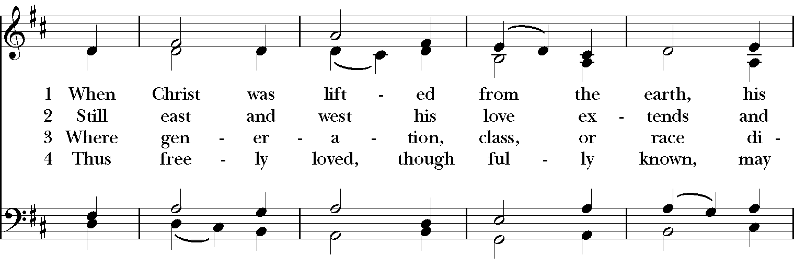  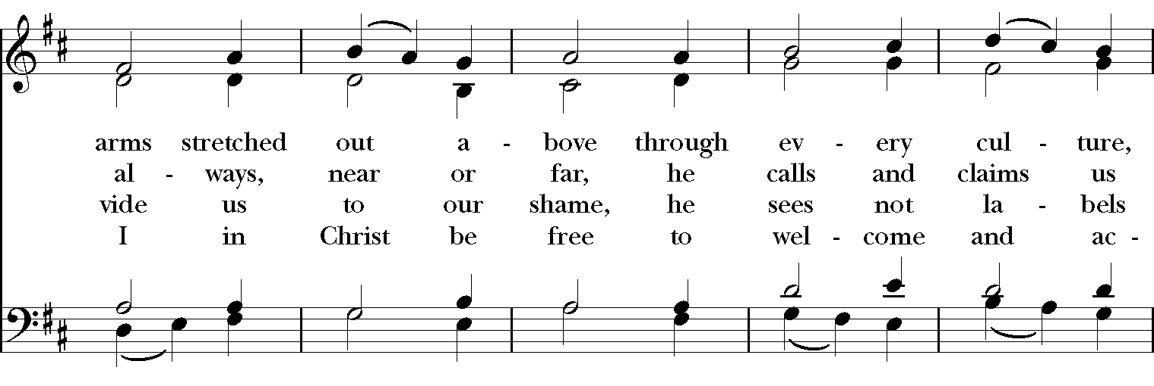  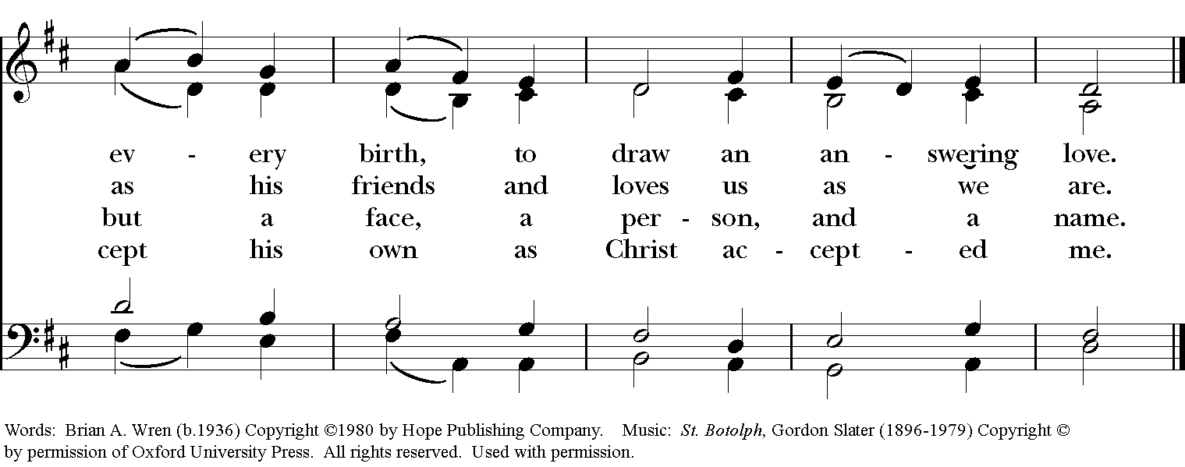
The Holy Gospel of our Savior Jesus Christ according to John John 15:12-17
People Glory to you, O Christ.
Jesus said, “This is my commandment, that you love one another as I have loved you. No one has greater love than this, to lay down one’s life for one’s friends. You are my friends if you do what I command you. I do not call you servants any longer, because the servant does not know what the master is doing; but I have called you friends, because I have made known to you everything that I have heard from my Father. You did not choose me but I chose you. And I appointed you to go and bear fruit, fruit that will last, so that the Father will give you whatever you ask him in my name. I am giving you these commands so that you may love one another.”
Priest The Gospel of Christ.
People Praise to you, O Christ.
All are seated at the invitation of the preacher. | The Homily Dr. Damon A. Darsey  Associate Professor of Emergency Medicine and Pediatrics  and Medical Director, Mississippi Center for Emergency Services
The people are invited to stand. | A Litany of Remembrance and Thanksgiving  Litanst Almighty God, Creator of heaven and earth,  People Have mercy upon us.  Litanist Beloved Son, Redeemer of the world,  People Have mercy upon us.  Litanst Holy Spirit, Sanctifier of us all,  People Have mercy upon us.  Litanst Glorious Trinity, one God,  People Have mercy upon us.  Litanst Hear our prayers of remembrance and thanksgiving.  People O God, hear our prayer.  Litanst We remember all who died on September 11,, 2001, who now rise from strength to strength in perfect peace, where sorrow and terror and pain are no more, but life everlasting.  People O God, hear our prayer.  Litanst We remember all who still grieve the death of family members, friends, and fellow citizens, that they may not sorrow without hope, but have confidence in your goodness and expectation of eternal life with those they love.  People O God, hear our prayer.  Litanst We remember all who still suffer in body, mind, or spirit, that their wounds may yet be healed by the power of your Holy Spirit.  People O God, hear our prayer.  Litanst We remember from that day our own fear and shock, our anger and confusion, our sorrow and grief; and we pray that where we yet tremble you would transform our darkness into light.  People O God, hear our prayer.  Litanst We pray for all victims of terror, war, and violence in this and every land, that your justice, and mercy and peace would prevail over the perpetration of every evil.  People O God, hear our prayer.  Litanst We give you thanks for the fearlessness of all emergency responders and service men and women in our community and throughout the world, who devote their lives to helping others in trouble, danger and need; protect them in their work and ministry among us.  People O God, hear our prayer.  Litanst We give you thanks for the example of Christ’s courage, selflessness, and love, even in the face of death; inspire and strengthen us to love and serve one another as he loved us.  People O God, hear our prayer.  Litanst We give you thanks for all who work for justice, freedom, and peace; help us all endure in this way, this truth, and this life until your reign is fulfilled.  People O God, hear our prayer.  Litanst We give you thanks for the hope that is ours through the resurrection of Jesus Christ from the dead, and pray that you would restore to wholeness whatever is broken by human sin in our lives, in our nation, and in the world.  People O God, hear our prayer.
The Presider then continues with a blessing for emergency responders and service women and men who are present. | Blessed are you, O God of mercy, who through your Son gave us a marvelous example of charity and the great commandment of love for one another: Send down your blessings on these your servants, who so generously devote themselves to helping others. Grant them courage when they are afraid, wisdom when they must make quick decisions, strength when they are weary, and compassion in all their work. When the alarm sounds and they are called to aid both friend and stranger, let them faithfully serve you in their neighbor. We ask this through Christ our Savior. Amen.  The Peace  Presider The peace of Christ be always with you.  People And also with you.
Welcome and Announcements

The Holy Communion
At the Offertory I Vow to Thee, My Country Gustav Holst, arr. James Kirkby
I vow to thee, my country, all earthly things above, Entire and whole and perfect, the service of my love; The love that asks no question, the love that stands the test, That lays upon the altar the dearest and the best; The love that never falters, the love that pays the price, The love that makes undaunted the final sacrifice. And there's another country, I've heard of long ago, Most dear to them that love her, most great to them that know; We may not count her armies, we may not see her King; Her fortress is a faithful heart, her pride is suffering; And soul by soul and silently her shining bounds increase, And her ways are ways of gentleness, and all her paths are peace.
All stand | The Great Thanksgiving, Eucharistic Prayer A  Presider The Lord be with you.  People And also with you.  Presider Lift up your hearts.  People We lift them to the Lord.  Presider Let us give thanks to the Lord our God.  People It is right to give our thanks and praise.
The Presider continues | It is right, and a good and joyful thing, always and everywhere to give thanks to you, Father Almighty, Creator of heaven and earth. For in the multitude of your saints you have surrounded us with a great cloud of witnesses, that we might rejoice in their fellowship, and run with endurance the race that is set before us; and, together with them, receive the crown of glory that never fades away. Therefore we praise you, joining our voices with Angels and Archangels and with all the company of heaven, who for ever sing this hymn to proclaim the glory of your Name:
Presider and people say together | Holy, holy, holy Lord, God of power and might, heaven and earth are full of your glory. Hosanna in the highest. Blessed is he who comes in the name of the Lord. Hosanna in the highest.
The People stand or kneel. | Holy and gracious Father: In your infinite love you made us for yourself; and, when we had fallen into sin and become subject to evil and death, you, in your mercy, sent Jesus Christ, your only and eternal Son, to share our human nature, to live and die as one of us, to reconcile us to you, the God and Father of all. He stretched out his arms upon the cross, and offered himself, in obedience to your will, a perfect sacrifice for the whole world.  On the night he was handed over to suffering and death, our Lord Jesus Christ took bread; and when he had given thanks to you, he broke it, and gave it to his disciples, and said, “Take, eat: This is my Body, which is given for you. Do this for the remembrance of me.”  After supper he took the cup of wine; and when he had given thanks, he gave it to them, and said, “Drink this, all of you: This is my Blood of the new Covenant, which is shed for you and for many for the forgiveness of sins. Whenever you drink it, do this for the remembrance of me.” Therefore we proclaim the mystery of faith:
All say | Christ has died. Christ is risen. Christ will come again.
We celebrate the memorial of our redemption, O Father, in this sacrifice of praise and thanksgiving. Recalling his death, resurrection, and ascension, we offer you these gifts.
Sanctify them by your Holy Spirit to be for your people the Body and Blood of your Son, the holy food and drink of new and unending life in him. Sanctify us also that we may faithfully receive this holy Sacrament, and serve you in unity, constancy, and peace; and at the last day bring us with all your saints into the joy of your eternal kingdom.
All this we ask through your Son Jesus Christ. By him, and with him, and in him, in the unity of the Holy Spirit all honor and glory is yours, Almighty Father, now and forever. AMEN.
All say | The Lord’s Prayer BCP, Page 364  Our Father, who art in heaven, hallowed be thy Name, thy kingdom come, thy will be done, on earth as it is in heaven. Give us this day our daily bread. And forgive us our trespasses, as we forgive those who trespass against us. And lead us not into temptation, but deliver us from evil. For thine is the kingdom, and the power, and the glory, for ever and ever. Amen.
The Presider breaks the consecrated Bread. A period of silence is kept. | The Fraction and Invitation  Presider Alleluia. Christ our Passover is sacrificed for us  People Therefore let us keep the feast. Alleluia.  Presider The Gifts of God for the People of God.
Holy Communion
The table of bread and wine is the table of company with Jesus, and all those who love him. So come to this table, you who have much faith, and you who would like to have more; you who have been to this Sacrament often, and you who have not been for a long time; you who have tried to follow Jesus in the world, and you who have failed; come. It is Christ who invites us to meet him here.
An usher will signal you at the pew when it is time to come forward. You may come forward to receive at the altar rail, or at the foot of the stairs. Please return to your pew by the side aisle.
For Holy Communion, receive the bread in the open palms. The wine may be taken from the common cup by drinking, placing your hand gently on the base of the chalice to guide it, or by carefully dipping the bread in the chalice. If you'd prefer not to receive Holy Communion but would instead like a blessing, please come forward and indicate that by crossing your arms over your chest. Gluten-free wafers are available upon request.
During Communion, all are welcome to join in singing the hymns on the following pages.

Music During Communion
Hymn, H-1982 #571 All who love and serve your city Charlestown
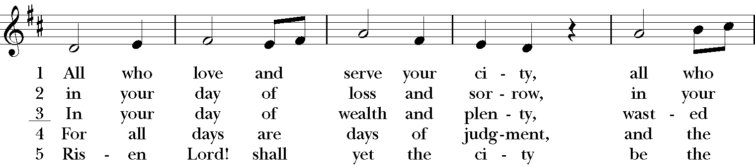
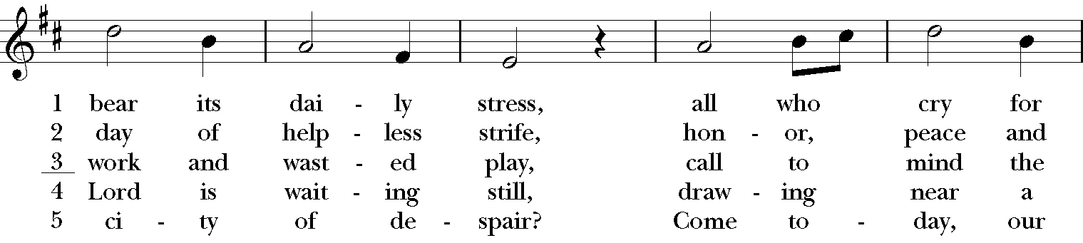
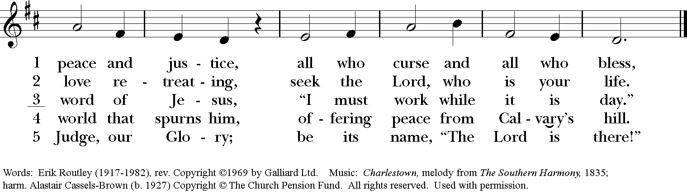
 | Hymn, H-1982 #304 I come with joy to meet my Lord Land of Rest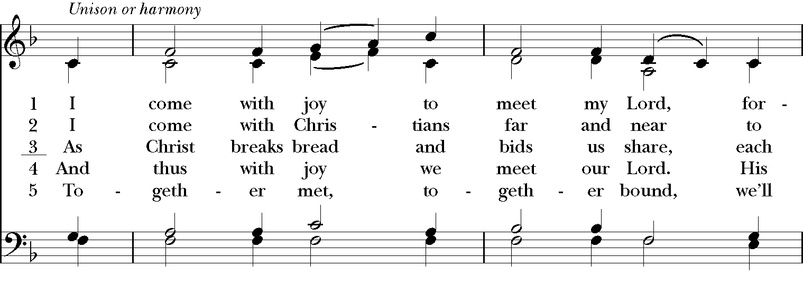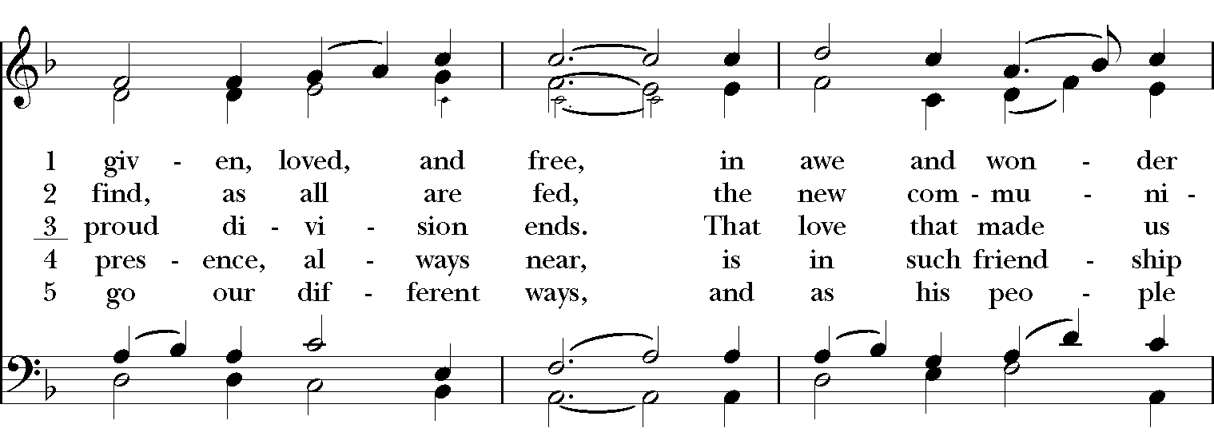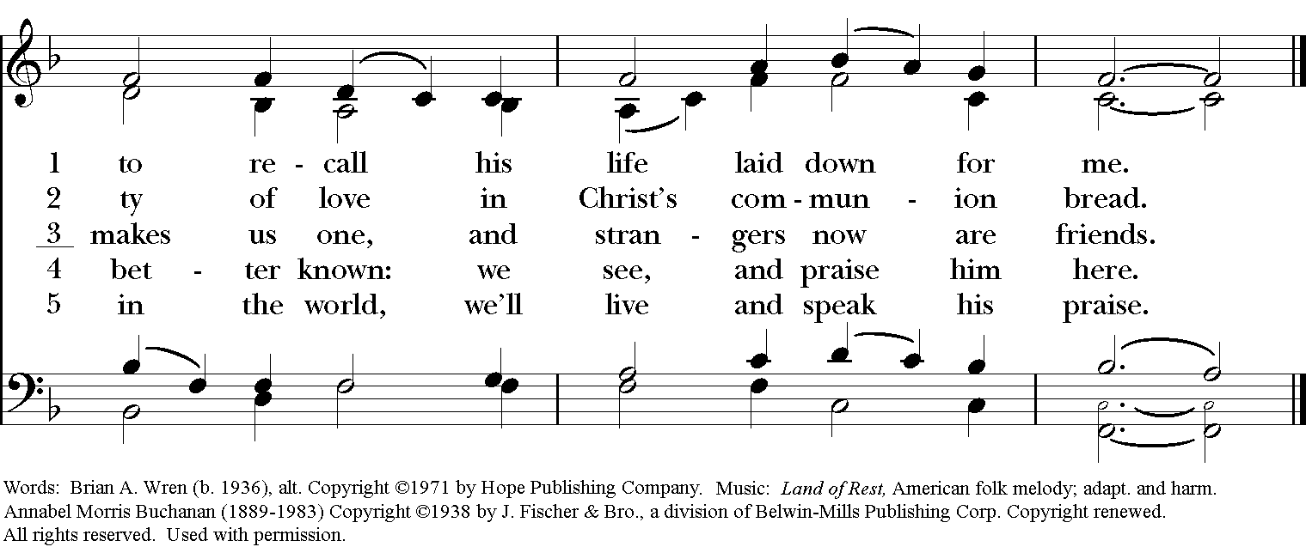
At the end of Holy Communion all stand and sing | Hymn, H-1982 #719 O Beautiful, for spacious skies Materna  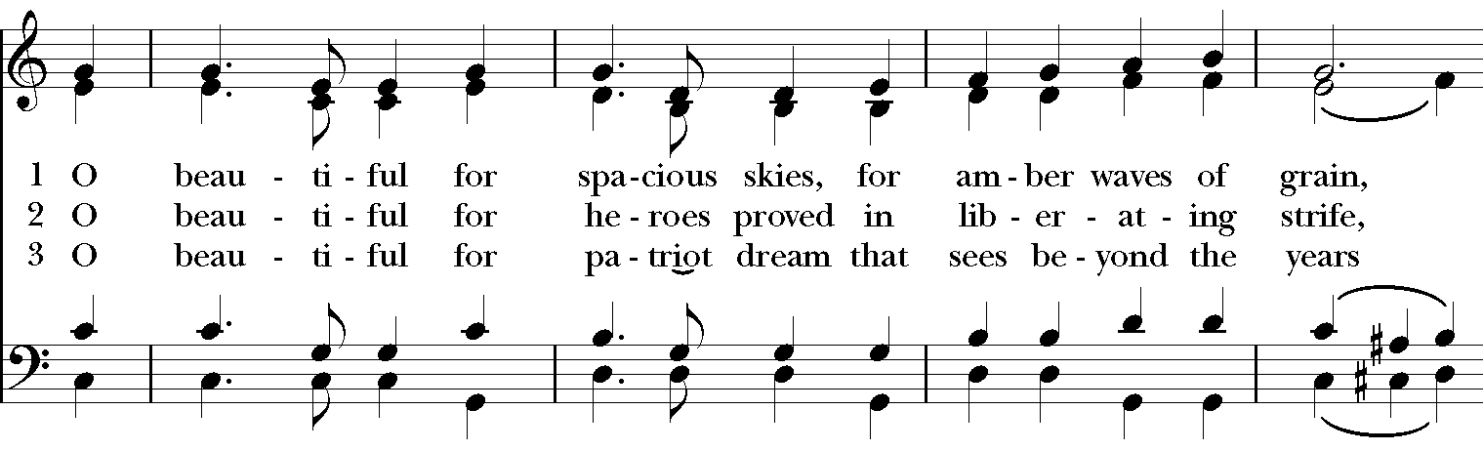  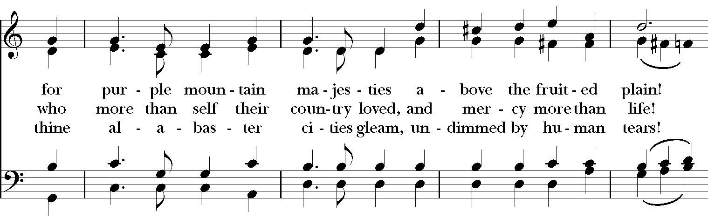  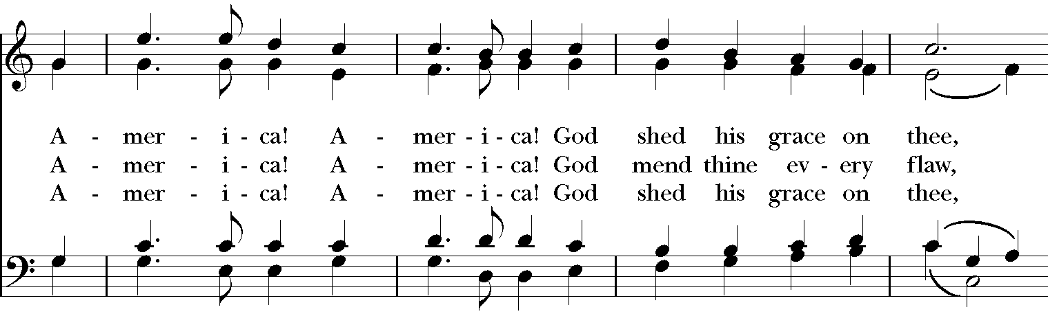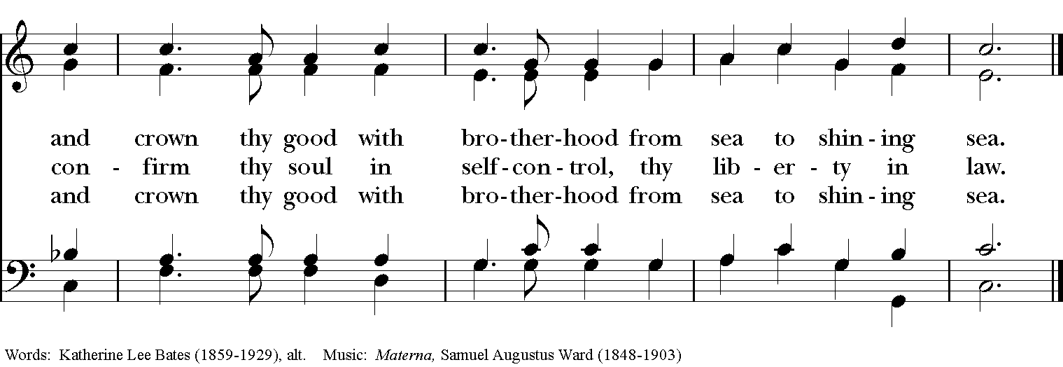
All say together. | Post-Communion Prayer, from Enriching our Worship I  God of abundance, you have fed us with the bread of life and cup of salvation; you have united us with Christ and one another; and you have made us one with all your people in heaven and on earth. Now send us forth in the power of your Spirit, that we may proclaim your redeeming love to the world and continue for ever in the risen life of Christ our Savior. Amen
The Priest blesses the people | Blessing  As you leave this place, go forth in peace. Be assured that the past is forgiven and the future is in God's hands. Return to no person evil for evil, Remember the poor, pray for the sick, and make no peace with injustice in this world, and the blessings of God Almighty, Father, Son, and Holy Spirit, be among you and remain with you always. Amen.  Dismissal  Priest Go in peace to love and to serve the Lord.  People Thanks be to God.  The bagpipes will lead the procession out to the tune of “Amazing Grace.”  All First Responders are asked to follow the procession to the front steps of the Cathedral.  Lunch is provided by the Cathedral in the Parish Hall and Courtyard for all.

Welcome Guests!
We are glad you have attended this Community Celebration of Holy Eucharist Honoring First Responders, and we hope you feel at home with us. Please take this service bulletin with you, so that you can refer to our service schedule and future events. If you have questions, please speak with the clergy or one of the greeters after the service. You can also call the office at any time and we will be happy to help you in any way we can.

Thank you for visiting St. Andrew’s Episcopal Cathedral today.
Go in peace and return often!

Weekly Worship Schedule
Sunday Mornings
- 7:30 a.m. Holy Eucharist · Rite I · No Music · Chapel
- 8:40 a.m. Holy Eucharist · Rite II · Music, Parish Choir · Cathedral
- 9:45 a.m. Formation and Fellowship
- 11:00 a.m. Holy Eucharist · Rite II · Music, Cathedral Choir · Cathedral
- 5:15 p.m. Evensong with Holy Eucharist · Music · Cathedral
Monday - Friday
- Noon - Holy Eucharist, with Healing on Thursday · Chapel

Special Worship Services
St. Andrew’s Pet Blessing
- October 6th at 4p.m. on the Columbarium beside West Street.
All animals and their humans are welcome!

Advent Lessons and Carols
- December 8th at 5p.m. in the Cathedral.
Through word and music this service will move us into a posture of watchful waiting
and hopeful expectation as we await the birth of Jesus.
A reception will follow the service in the Parish Hall.

