St. Andrew’s Episcopal Cathedral
Eighth Sunday after Pentecost
August 4, 2019 | Rite II 10:00 a.m.
305 E. Capitol St | Jackson MS, 39201 standrews.ms 601-354-1535

Welcome to St. Andrew’s Episcopal Cathedral! We are glad we can worship together today. If you are a newcomer, please complete a Welcome Card and place it in the offering plate so we can extend our welcome beyond this service. Following the service, join us in the Parish Hall for a reception as we bid farewell to our Director of Communications, Josh Geter.

.

Ministry of the Word
Prelude Prélude Paul Benoit

All stand at the ringing of the tower bell. | Hymn, H-1982 #48 O Day of Radiant Gladness Es flog ein kleins Waldvögelein  Opening Acclamation  Presider Blessed be the one, holy, and living God.  People Glory to God for ever and ever. Amen.  Collect for Purity BCP, Page 355  Almighty God, to you all hearts are open, all desires known, and from you no secrets are hid: Cleanse the thoughts of our hearts by the inspiration of your Holy Spirit, that we may perfectly love you, and worthily magnify your holy Name; through Christ our Lord. Amen.  Song of Praise, H-1982 #S-280  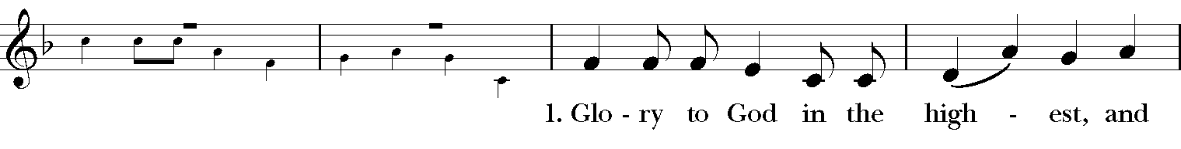  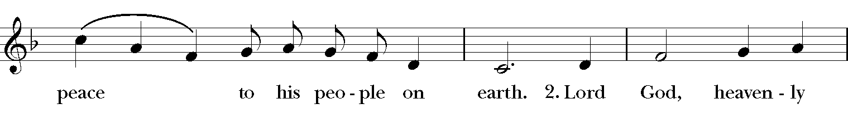  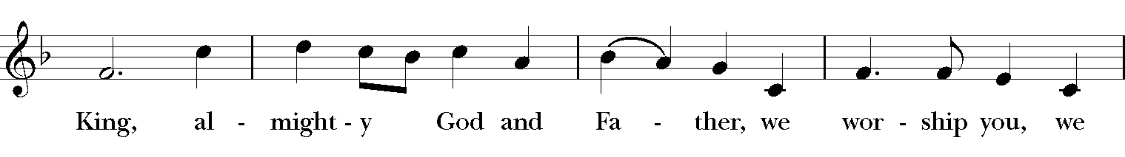  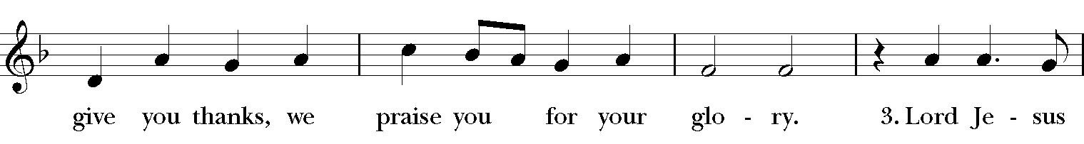  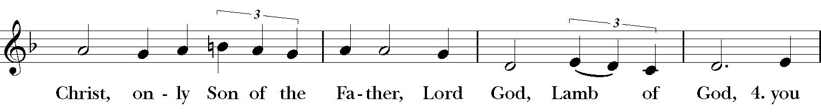  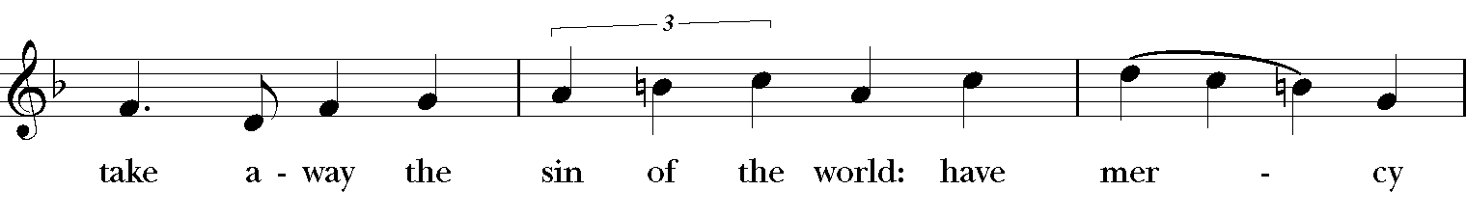  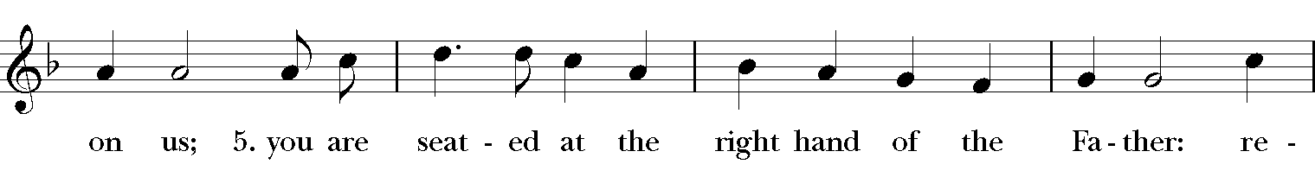  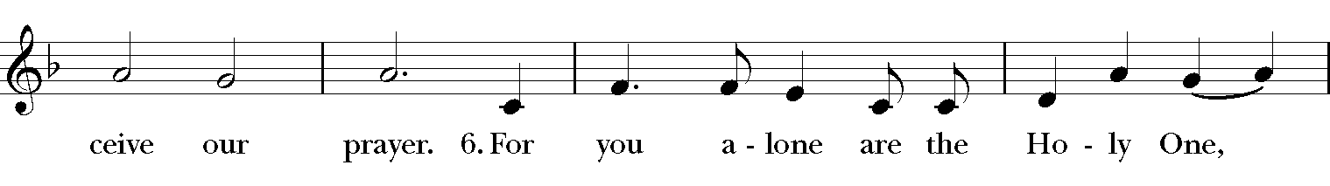  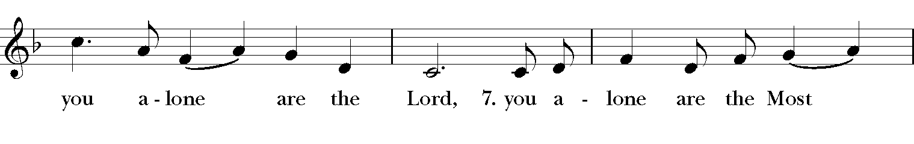  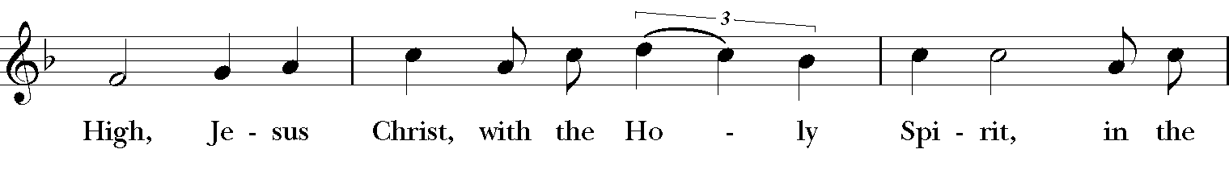  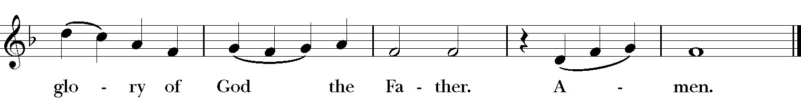  Collect of the Day  Presider The Lord be with you.  People And also with you.  Presider Let us pray.  Let your continual mercy, O Lord, cleanse and defend your Church; and, because it cannot continue in safety without your help, protect and govern it always by your goodness; through Jesus Christ our Lord, who lives and reigns with you and the Holy Spirit, one God, for ever and ever. Amen.
All are now seated for the reading from Holy Scripture. | A Reading From Ecclesiastes Ecclesiastes 1:2, 12-14; 2:18-23  Vanity of vanities, says the Teacher, vanity of vanities! All is vanity. I, the Teacher, when king over Israel in Jerusalem, applied my mind to seek and to search out by wisdom all that is done under heaven; it is an unhappy business that God has given to human beings to be busy with. I saw all the deeds that are done under the sun; and see, all is vanity and a chasing after wind. I hated all my toil in which I had toiled under the sun, seeing that I must leave it to those who come after me -- and who knows whether they will be wise or foolish? Yet they will be master of all for which I toiled and used my wisdom under the sun. This also is vanity. So I turned and gave my heart up to despair concerning all the toil of my labors under the sun, because sometimes one who has toiled with wisdom and knowledge and skill must leave all to be enjoyed by another who did not toil for it. This also is vanity and a great evil. What do mortals get from all the toil and strain with which they toil under the sun? For all their days are full of pain, and their work is a vexation; even at night their minds do not rest. This also is vanity.  Reader The Word of the Lord.  People Thanks be to God.
 | 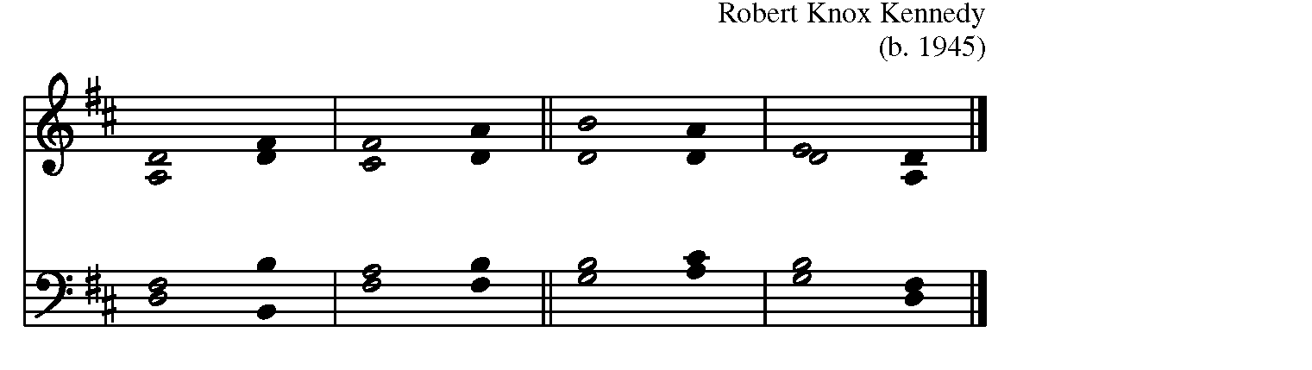
Sung by all | Psalm 49:1-11
 | 1 Hear this, all you peoples;  hearken, all you who dwell in the / world, *  you of high degree and low, rich and poor to/gether.  2 My mouth shall speak of / wisdom, *  and my heart shall meditate on under/standing.  3 I will incline my ear to a / proverb *  and set forth my riddle upon the / harp.  4 Why should I be afraid in evil / days, *  when the wickedness of those at my heels sur/rounds me,  5 The wickedness of those who put their trust in their / goods, *  and boast of their great / riches?  6 We can never ransom our/selves, *  or deliver to God the price of our / life; | 7 For the ransom of our life is so / great, *  that we should never have enough to / pay it,  8 In order to live for ever and / ever, *  and never see the / grave.  9 For we see that the wise die also;  like the dull and stupid they / perish *  and leave their wealth to those who come / after them.  10 Their graves shall be their homes for ever,  their dwelling places from generation to gene/ration, *  though they call the lands after their own / names.  11 Even though honored they cannot live for / ever; *  they are like the beasts that / perish.
A Reading from Colossians Colossians 3:1-11
If you have been raised with Christ, seek the things that are above, where Christ is, seated at the right hand of God. Set your minds on things that are above, not on things that are on earth, for you have died, and your life is hidden with Christ in God. When Christ who is your life is revealed, then you also will be revealed with him in glory. Put to death, therefore, whatever in you is earthly: fornication, impurity, passion, evil desire, and greed (which is idolatry). On account of these the wrath of God is coming on those who are disobedient. These are the ways you also once followed, when you were living that life. But now you must get rid of all such things-- anger, wrath, malice, slander, and abusive language from your mouth. Do not lie to one another, seeing that you have stripped off the old self with its practices and have clothed yourselves with the new self, which is being renewed in knowledge according to the image of its creator. In that renewal there is no longer Greek and Jew, circumcised and uncircumcised, barbarian, Scythian, slave and free; but Christ is all and in all!
Reader The Word of the Lord.
People Thanks be to God.

All now stand. All sing the following as the gospel procession moves into the congregation. At this time, children ages 3 to 5 are invited to follow the Children's Chapel Leaders to the Chapel. Older children are invited to come and serve as helpers. | Hymn, H-1982 #617 Eternal Ruler of the Ceaseless Round Song 1  The Holy Gospel of our Savior Jesus Christ according to Luke Luke 12:13-21  People Glory to you, O Christ.  Someone in the crowd said to Jesus, "Teacher, tell my brother to divide the family inheritance with me." But he said to him, "Friend, who set me to be a judge or arbitrator over you?" And he said to them, "Take care! Be on your guard against all kinds of greed; for one's life does not consist in the abundance of possessions." Then he told them a parable: "The land of a rich man produced abundantly. And he thought to himself, `What should I do, for I have no place to store my crops?' Then he said, `I will do this: I will pull down my barns and build larger ones, and there I will store all my grain and my goods. And I will say to my soul, `Soul, you have ample goods laid up for many years; relax, eat, drink, be merry.' But God said to him, `You fool! This very night your life is being demanded of you. And the things you have prepared, whose will they be?' So it is with those who store up treasures for themselves but are not rich toward God."  Priest The Gospel of Christ.  People Praise to you, O Christ.
All are seated at the invitation of the preacher and remain seated following the sermon. Then all stand and say | Sermon The Reverend Canon Jennifer Deaton, Canon for Pastoral Care  Musical Reflection  Nicene Creed BCP, Page 358  We believe in one God, the Father, the Almighty, maker of heaven and earth, of all that is, seen and unseen. We believe in one Lord, Jesus Christ, the only Son of God, eternally begotten of the Father, God from God, Light from Light, true God from true God, begotten, not made, of one Being with the Father. Through him all things were made. For us and for our salvation he came down from heaven: by the power of the Holy Spirit he became incarnate from the Virgin Mary, and was made man. For our sake he was crucified under Pontius Pilate; he suffered death and was buried. On the third day he rose again in accordance with the Scriptures; he ascended into heaven and is seated at the right hand of the Father. He will come again in glory to judge the living and the dead, and his kingdom will have no end. We believe in the Holy Spirit, the Lord, the giver of life, who proceeds from the Father and the Son. With the Father and the Son he is worshiped and glorified. He has spoken through the Prophets. We believe in one holy catholic and apostolic Church. We acknowledge one baptism for the forgiveness of sins. We look for the resurrection of the dead, and the life of the world to come. Amen
The Priest introduces the prayers, which are then led by an Intercessor. The People respond with the words in bold print. | Prayers of the People Based on Form VI BCP, Page 392  Let us pray for people everywhere through Jesus Christ, who is all in all. In the pauses, you are welcome to name aloud those persons or situations for which you pray.  In peace we pray to you, O God.  For all people in their daily life and work;  For our families, friends and neighbors, and for those who are alone.  For this community, the nation, and the world;  For all who work for justice, freedom, and peace.  For the just and proper use of your creation;  For the victims of hunger, fear, injustice, and oppression.  For all who are in danger, sorrow, or any kind of trouble;  For those who minister to the sick, the friendless, and the needy.  For Michael our Presiding Bishop, Brian our Bishop; and for all bishops and other ministers.  For all who serve God in his Church.  For the special needs and concerns of this congregation.  Hear us, Lord;  For your mercy is great.  We thank you, Lord, for all the blessings of this life.  We will exalt you, O God our King;  And praise your name for ever and ever.  We pray for all who have died, that they may have a place in your eternal kingdom.  Lord, let your loving-kindness be upon them;  Who put their trust in you.
 | Confession and Absolution BCP, Page 393
We pray to you also for the forgiveness of our sins.
Silence may be kept.
The people may stand or kneel. Then all say | Have mercy upon us, most merciful God; in your compassion forgive us our sins, known and unknown, things done and left undone; and so uphold us by your Spirit that we may live and serve you in newness of life, to the honor and glory of your Name; through Jesus Christ our Savior. Amen.
The Presider pronounces Absolution, saying | Almighty God, have mercy upon you, forgive you all your sins through the grace of Jesus Christ, strengthen you in all goodness, and by the power of the Holy Spirit keep you in eternal life. Amen.
The Peace BCP, Page 360
Presider The peace of Christ be always with you.
People And also with you.
Welcome and Announcements
Ministry of the Table
At the Offertory Jesu, Joy of Man’s Desiring J.S. Bach Alex Sullivan, violin
All stand and sing | Hymn Praise God from Whom All Blessings Flow Lasst Uns Erfreuen  Praise God from whom all blessings flow;  Praise God, all creatures here below; Alleluia! Alleluia!  Praise God above, ye heavenly host:  Praise Father, Son, and Holy Ghost,  O praise him, O praise him, Alleluia, alleluia, alleluia.
The Great Thanksgiving, Enriching our Worship, Prayer I
Presider The Lord be with you.
People And also with you.
Presider Lift up your hearts.
People We lift them to the Lord.
Presider Let us give thanks to the Lord our God.
People It is right to give our thanks and praise.
The Presider continues | It is truly right, and good and joyful, to give you thanks, all-holy God, source of life and fountain of mercy. You have filled us and all creation with your blessing and fed us with your constant love; you have redeemed us in Jesus Christ and knit us into one body. Through your Spirit you replenish us and call us to fullness of life. Therefore, joining with Angels and Archangels and with the faithful of every generation, we lift our voices with all creation as we sing.  Sanctus H-1982 #S-124 from New Plainsong Mass, David Hurd  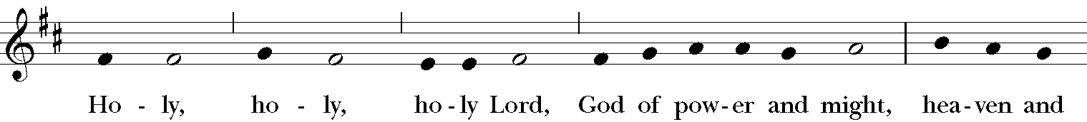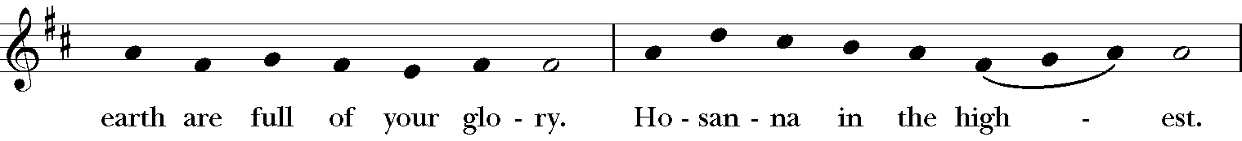  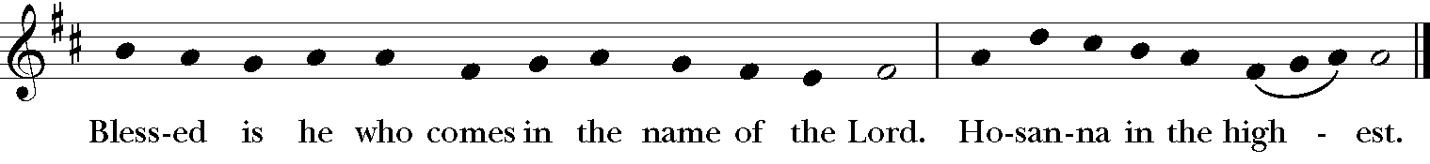
The People stand or kneel. Then the Presider continues | Blessed are you, gracious God, creator of the universe and giver of life. You formed us in your own image and called us to dwell in your infinite love. You gave the world into our care that we might be your faithful stewards and show forth your bountiful grace. But we failed to honor your image in one another and in ourselves; we would not see your goodness in the world around us; and so we violated your creation, abused one another, and rejected your love. Yet you never ceased to care for us, and prepared the way of salvation for all people. Through Abraham and Sarah you called us into covenant with you. You delivered us from slavery, sustained us in the wilderness, and raised up prophets to renew your promise of salvation. Then, in the fullness of time, you sent your eternal Word, made mortal flesh in Jesus. Born into the human family, and dwelling among us, he revealed your glory. Giving himself freely to death on the cross, he triumphed over evil, opening the way of freedom and life.  On the night before he died for us, Our Savior Jesus Christ took bread, and when he had given thanks to you, he broke it, and gave it to his friends, and said: “Take, eat: This is my Body which is given for you. Do this for the remembrance of me.” As supper was ending, Jesus took the cup of wine, and when he had given thanks, he gave it to them, and said: “Drink this, all of you: This is my Blood of the new Covenant, which is poured out for you and for all for the forgiveness of sins. Whenever you drink it, do this for the remembrance of me.” Therefore we proclaim the mystery of faith:
All say | Christ has died. Christ is risen. Christ will come again.
The Presider continues | Remembering his death and resurrection, we now present to you from your creation this bread and this wine. By your Holy Spirit may they be for us the Body and Blood of our Savior Jesus Christ. Grant that we who share these gifts may be filled with the Holy Spirit and live as Christ’s Body in the world. Bring us into the everlasting heritage of your daughters and sons, that with Andrew and all your saints, past, present, and yet to come, we may praise your Name for ever. Through Christ and with Christ and in Christ, in the unity of the Holy Spirit, to you be honor, glory, and praise, for ever and ever. AMEN
All say | The Lord’s Prayer BCP, Page 364  Our Father, who art in heaven, hallowed be thy Name, thy kingdom come, thy will be done, on earth as it is in heaven. Give us this day our daily bread. And forgive us our trespasses, as we forgive those who trespass against us. And lead us not into temptation, but deliver us from evil. For thine is the kingdom, and the power, and the glory, for ever and ever. Amen.
The Presider breaks the consecrated Bread to be shared with the congregation. A period of silence is kept. The following anthem is then sung by all. | The Fraction H-1982 #S154 Christ our Passover from New Plainsong Mass, David Hurd  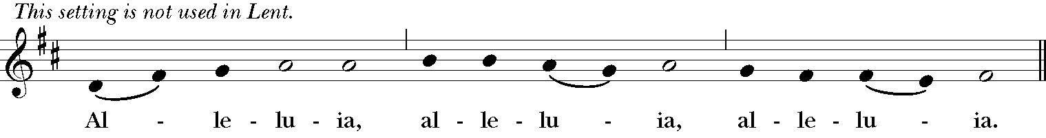  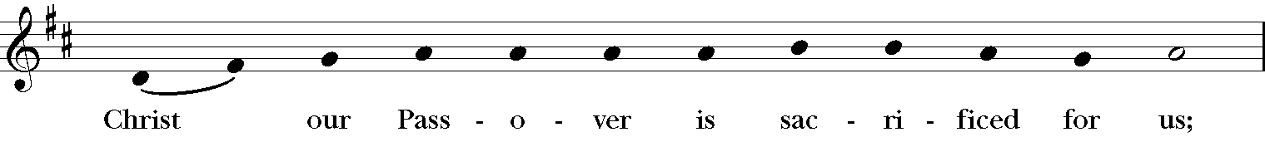  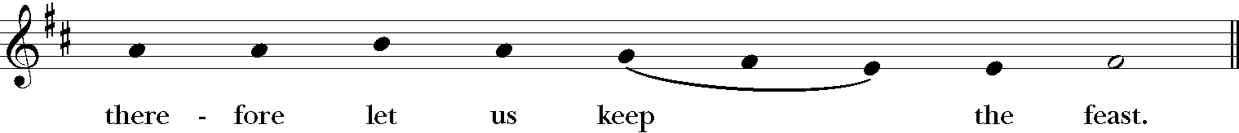  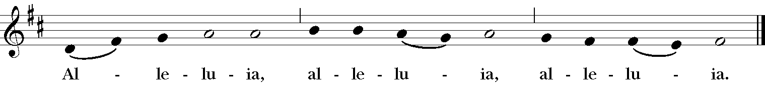
Holy Communion
The table of bread and wine is the table of company with Jesus, and all those who love him. So come to this table, you who have much faith, and you who would like to have more; you who have been to this Sacrament often, and you who have not been for a long time; you who have tried to follow Jesus in the world, and you who have failed; come. It is Christ who invites us to meet him here.
For Holy Communion, receive the bread in the open palms. The wine may be taken from the common cup by drinking, placing your hand gently on the base of the chalice to guide it, or by carefully dipping the bread in the chalice. If you'd prefer not to receive Holy Communion but would instead like a blessing, please come forward and indicate that by crossing your arms over your chest. Gluten-free wafers are available upon request.
Music During Communion
Hymn, LEVAS #151 One Bread, One Body One Bread, One Body

1 Gentile or Jew, servant or free,
woman or man, no more.
One Lord.

2 Many the gifts, many the works,
one in the Lord of all.
One Lord.

3 Grain for the fields, scattered and grown,
gathered to one for all.
One Lord.
Hymn, H-1982 #335 I Am the Bread of Life I am the Bread of Life
All stand and say together | Post-Communion Prayer, from Enriching our Worship I  God of abundance, you have fed us with the bread of life and cup of salvation; you have united us with Christ and one another; and you have made us one with all your people in heaven and on earth. Now send us forth in the power of your Spirit, that we may proclaim your redeeming love to the world and continue for ever in the risen life of Christ our Savior. Amen
As the procession passes down the aisle, the people turn and face the doors of the Cathedral. The Priest dismisses the people, who respond | Blessing  Hymn, H-1982 #607 O God of Every Nation Llangloffan  Dismissal  People Thanks be to God.  Postlude Trumpet Tune in G John Dixon

Flowers on the Altar in the Chapel are given to the
Glory of God and in loving memory of
Howard Spencer Jones,
Katie Lampton and
Dr. Harvey Johnston
Given by
Susan Shands Jones

