Saint Andrew’s Episcopal Cathedral
The Fifth Sunday in Easter – April 29, 2018
Celebration of Holy Eucharist, Rite II – 8:45 and 11:00 a.m.

Ministry of the Word

Prelude Prelude and Variation in e-minor Johann Heinrich Buttstedt

All stand at the chiming of the bells.

Hymn, H-1982 #657 Love Divine, All Loves Excelling Hyfrydol

Easter Acclamation The Book of Common Prayer (BCP), page 355

Presider Alleluia! Christ is Risen!
People The Lord is risen indeed! Alleluia!

Collect for Purity BCP, Page 355

Almighty God, to you all hearts are open, all desires known, and from you no secrets are hid: Cleanse the thoughts of our hearts by the inspiration of your Holy Spirit, that we may perfectly love you, and worthily magnify your holy Name; through Christ our Lord. Amen.

Song of Praise, H-1982 #S-266 A Song to the Lamb Calvin Hampton
The antiphon is sung first by the choir and thereafter by all the people.

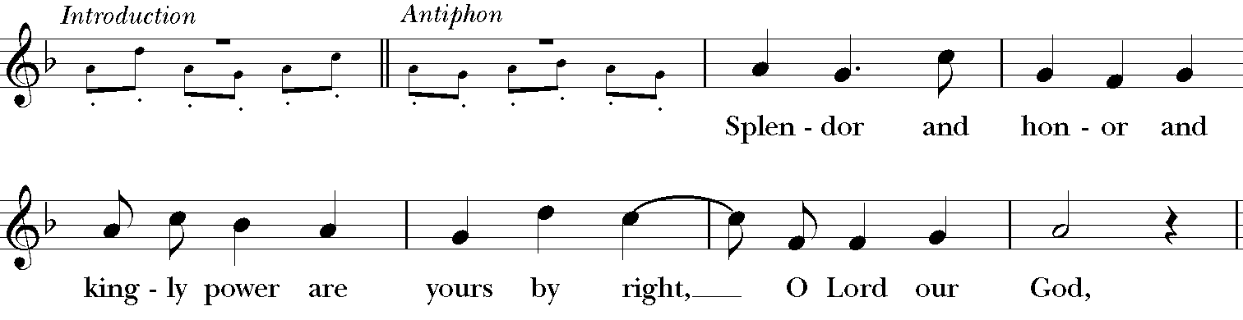

Collect of the Day

Presider The Lord be with you.
People And also with you.
Presider Let us pray.

Almighty God, whom truly to know is everlasting life: Grant us so perfectly to know your Son Jesus Christ to be the way, the truth, and the life, that we may steadfastly follow his steps in the way that leads to eternal life; through Jesus Christ your Son our Lord, who lives and reigns with you, in the unity of the Holy Spirit, one God, for ever and ever. Amen.

First Lesson Acts 8:26-40
An angel of the Lord said to Philip, “Get up and go toward the south to the road that goes down from Jerusalem to Gaza.” (This is a wilderness road.) So he got up and went. Now there was an Ethiopian eunuch, a court official of the Candace, queen of the Ethiopians, in charge of her entire treasury. He had come to Jerusalem to worship and was returning home; seated in his chariot, he was reading the prophet Isaiah. Then the Spirit said to Philip, “Go over to this chariot and join it.” So Philip ran up to it and heard him reading the prophet Isaiah. He asked, “Do you understand what you are reading?” He replied, “How can I, unless someone guides me?” And he invited Philip to get in and sit beside him. Now the passage of the scripture that he was reading was this: “Like a sheep he was led to the slaughter, and like a lamb silent before its shearer, so he does not open his mouth. In his humiliation justice was denied him. Who can describe his generation? For his life is taken away from the earth.” The eunuch asked Philip, “About whom, may I ask you, does the prophet say this, about himself or about someone else?” Then Philip began to speak, and starting with this scripture, he proclaimed to him the good news about Jesus. As they were going along the road, they came to some water; and the eunuch said, “Look, here is water! What is to prevent me from being baptized?” He commanded the chariot to stop, and both of them, Philip and the eunuch, went down into the water, and Philip baptized him. When they came up out of the water, the Spirit of the Lord snatched Philip away; the eunuch saw him no more, and went on his way rejoicing. But Philip found himself at Azotus, and as he was passing through the region, he proclaimed the good news to all the towns until he came to Caesarea.

Reader The Word of the Lord.
People Thanks be to God.

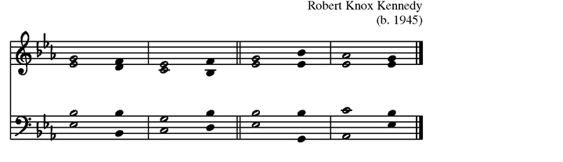
Psalm 22:24-30
24 My praise is of him in the great as/sembly; *
I will perform my vows in the presence of those who / worship him.

25 The poor shall eat and be satisfied,
and those who seek the Lord shall / praise him: *
"May your heart live for / ever!"

26 All the ends of the earth shall remember
and turn to the / Lord, *
and all the families of the nations shall bow be/fore him.

27 For kingship belongs to the / Lord; *
he rules over the/ nations.

28 To him alone all who sleep in the earth
bow down in / worship; *
all who go down to the dust fall be/fore him.

29 My soul shall live for him;
my descendants shall / serve him; *
they shall be known as the Lord's for / ever.

30 They shall come and make known to a people yet un/born *
the saving deeds that he has / done.

Second Lesson 1 John 4:7-21
Beloved, let us love one another, because love is from God; everyone who loves is born of God and knows God. Whoever does not love does not know God, for God is love. God's love was revealed among us in this way: God sent his only Son into the world so that we might live through him. In this is love, not that we loved God but that he loved us and sent his Son to be the atoning sacrifice for our sins. Beloved, since God loved us so much, we also ought to love one another. No one has ever seen God; if we love one another, God lives in us, and his love is perfected in us. By this we know that we abide in him and he in us, because he has given us of his Spirit. And we have seen and do testify that the Father has sent his Son as the Savior of the world. God abides in those who confess that Jesus is the Son of God, and they abide in God. So we have known and believe the love that God has for us. God is love, and those who abide in love abide in God, and God abides in them. Love has been perfected among us in this: that we may have boldness on the day of judgment, because as he is, so are we in this world. There is no fear in love, but perfect love casts out fear; for fear has to do with punishment, and whoever fears has not reached perfection in love. We love because he first loved us. Those who say, "I love God," and hate their brothers or sisters, are liars; for those who do not love a brother or sister whom they have seen, cannot love God whom they have not seen. The commandment we have from him is this: those who love God must love their brothers and sisters also.

Reader The Word of the Lord.
People Thanks be to God.

All now stand. All sing the following refrain as the gospel procession moves into the congregation. After the gospel is read, the refrain is repeated again as the procession returns. At this time, children ages 3 to 5 are invited to follow the Children's Chapel Leaders to the Chapel. Older children are invited to come and serve as helpers.

Celtic Alleluia from the Taizé tradition
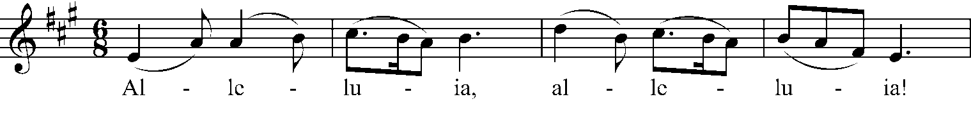
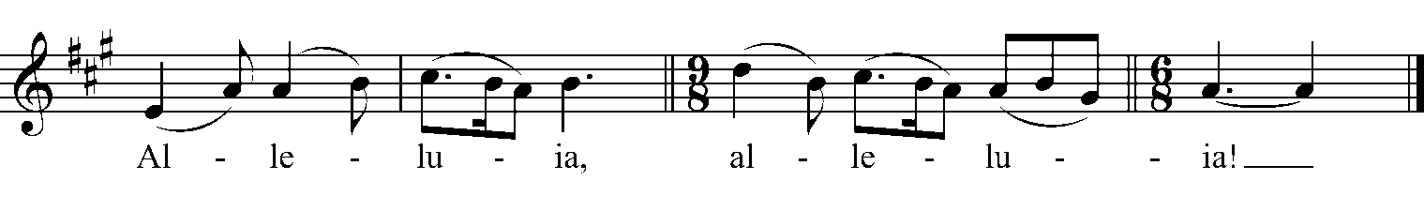

Gospel John 15:1-8

Deacon The Holy Gospel of our Savior Jesus Christ, according to John.
People Glory to you, O Christ.

Jesus said to his disciples, ”I am the true vine, and my Father is the vinegrower. He removes every branch in me that bears no fruit. Every branch that bears fruit he prunes to make it bear more fruit. You have already been cleansed by the word that I have spoken to you. Abide in me as I abide in you. Just as the branch cannot bear fruit by itself unless it abides in the vine, neither can you unless you abide in me. I am the vine, you are the branches. Those who abide in me and I in them bear much fruit, because apart from me you can do nothing. Whoever does not abide in me is thrown away like a branch and withers; such branches are gathered, thrown into the fire, and burned. If you abide in me, and my words abide in you, ask for whatever you wish, and it will be done for you. My Father is glorified by this, that you bear much fruit and become my disciples.”

Deacon The Gospel of Christ.
People Praise to you, O Christ.

Sermon The Reverend Jennifer Deaton, Canon for Pastoral Care

Following the sermon, a brief silence is observed for reflection

Nicene Creed

We believe in one God, the Father, the Almighty, maker of heaven and earth, of all that is, seen and unseen. We believe in one Lord, Jesus Christ, the only Son of God, eternally begotten of the Father, God from God, Light from Light, true God from true God, begotten, not made, of one Being with the Father. Through him all things were made. For us and for our salvation he came down from heaven: by the power of the Holy Spirit he became incarnate from the Virgin Mary, and was made man. For our sake he was crucified under Pontius Pilate; he suffered death and was buried. On the third day he rose again in accordance with the Scriptures; he ascended into heaven and is seated at the right hand of the Father. He will come again in glory to judge the living and the dead, and his kingdom will have no end. We believe in the Holy Spirit, the Lord, the giver of life, who proceeds from the Father and the Son. With the Father and the Son he is worshiped and glorified. He has spoken through the Prophets. We believe in one holy catholic and apostolic Church. We acknowledge one baptism for the forgiveness of sins. We look for the resurrection of the dead, and the life of the world to come. Amen.

Prayers of the People BCP, Page 389

The prayers call to mind the needs, concerns, and hopes of the congregation and of the world. Throughout the season of Easter, our prayers are drawn from Form V, found in the Book of Common Prayer. The Deacon bids the prayers, which are then led by an Intercessor.

Intercessor Risen Christ,
People Hear our prayer.

The Presider then concludes the Prayers.

O God, who wonderfully created, and yet more wonderfully restored, the dignity of human nature: Grant that we may share the divine life of him who humbled himself to share our humanity, your Son Jesus Christ; who lives and reigns with you, in the unity of the Holy Spirit, one God, for ever and ever. Amen.

The Peace

Presider The peace of Christ be always with you.
People And also with you.

Welcome and Announcements

Ministry of the Table

At this time the children will process into the service with their gifts and sit at the altar for the Celebration of Holy Eucharist. Children will return to their parents at the beginning of Communion.

Offertory Anthem Beneath the Forms of Outward Rite Leo Sowerby, arr. Lovelace

Beneath the forms of outward rite Thy supper, Lord, is spread
In every quiet upper room Where fainting souls are fed.

The bread is always consecrate Which all divide with all;
And every act of Christian love Repeats the feast again.

The blessed cup is only passed True memory of thee,
When life anew pours out its wine With rich sufficiency.

O Master, through these symbols shared, Thine own dear self impart,
That in our daily life may flame The passion of thy heart.
James A. Blaisdell, text

Hymn, H-1982 #487 Come, My Way, My Truth, My Life The Call

The Great Thanksgiving, Eucharistic Prayer A BCP, Page 361

Presider The Lord be with you.
People And also with you.
Presider Lift up your hearts.
People We lift them to the Lord.
Presider Let us give thanks to the Lord our God.
People It is right to give our thanks and praise.

The Presider continues

It is right, and a good and joyful thing, always and everywhere to give thanks to you.../ / ...Therefore we praise you, joining our voices with Angels and Archangels and with all the company of heaven, who for ever sing this hymn to proclaim the glory of your Name:

Sanctus H-1982 #S-125 Richard Proulx

Holy, holy, holy Lord, God of power and might, heaven and earth are full of your glory. Hosanna in the highest. Blessed is he who comes in the name of the Lord. Hosanna in the highest.

The People may stand or kneel. The Presider continues

Holy and gracious Father: In your infinite love you made us for yourself.../ /...therefore we proclaim the mystery of faith:

Presider and People

Christ has died. Christ is risen. Christ will come again

The Presider continues

We celebrate the memorial of our redemption, O Father.../ /...All this we ask through your Son Jesus Christ: By him, and with him, and in him, in the unity of the Holy Spirit all honor and glory is yours, Almighty Father, now and for ever. AMEN.

The Lord’s Prayer BCP, Page 364

Our Father, who art in heaven, hallowed be thy Name, thy kingdom come, thy will be done, on earth as it is in heaven. Give us this day our daily bread. And forgive us our trespasses, as we forgive those who trespass against us. And lead us not into temptation, but deliver us from evil. For thine is the kingdom, and the power, and the glory, for ever and ever. Amen.

The Presider breaks the consecrated Bread to be shared with the congregation. A period of silence is kept. The following anthem is then sung.

The Fraction Christ our Passover Richard Proulx

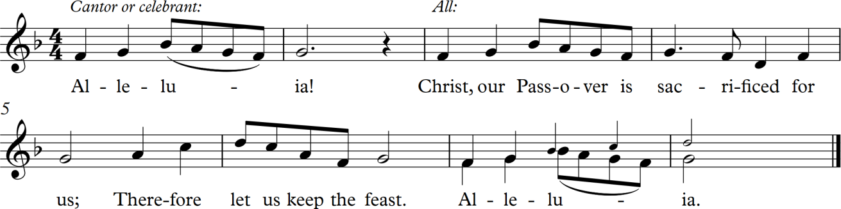

Holy Communion

The table of bread and wine is the table of company with Jesus, and all those who love him. So come to this table, you who have much faith, and you who would like to have more; you who have been to this Sacrament often, and you who have not been for a long time; you who have tried to follow Jesus in the world, and you who have failed; come. It is Christ who invites us to meet him here.

For Holy Communion, receive the bread in the open palms. The wine may be taken from the common cup by drinking, placing your hand gently on the base of the chalice to guide it, or by carefully dipping the bread in the chalice. If you'd prefer not to receive Holy Communion but would instead like a blessing, please come forward and indicate that by crossing your arms over your chest. Gluten-free wafers are available upon request.

Music During Communion

Hymn Thou Art the Way (see insert) Walton
H-1982 #463 He is the Way Hall

Doxology

Praise God from Whom all blessings flow; Praise Him, all creatures here below; Praise Him above, ye heavenly host; Praise Father, Son, and Holy Ghost.

Dismissal of the Lay Eucharistic Visitors (8:45 only)

In the Name of this congregation, we send you forth bearing these Holy gifts that those to whom you go may share with us in the Communion of Christ’s body and
blood. We who are many share one bread, one cup, because we are one body in Christ Jesus. Amen.

Prayer for Christian Discipleship BCP, Page 365

Eternal God, heavenly Father, you have graciously accepted us as living members of your Son our Savior Jesus Christ, and you have fed us with spiritual food in the sacrament of his Body and Blood. Send us now into the world in peace, and grant us strength and courage to love and serve you with gladness and singleness of heart; through Christ our Lord. Amen.

Blessing

The Presider now blesses the people to be sent out into the world in God’s service. As the procession passes down the aisle, the people turn and face the doors of the Cathedral.

Hymn, H-1982 #473 Lift High the Cross Crucifer

Dismissal

The Deacon dismisses the people, who respond

People Thanks be to God. Alleluia, Alleluia!

Postlude Variation Six Johann Heinrich Buttstedt

St. Andrew's Episcopal Cathedral
www.facebook.com/yourcathedralinthecity
305 E. Capitol St | Jackson MS, 39201
standrews.ms | 601-354-1535

